Weblog Analysis Using Hadoop

Gauri D. Kalyankar | Shivananda R Poojara | N V Dharwadkar
Email:gaurikalyankar93@gmail.com | Email: shivananda.poojara@ritindia.edul | Email: nagaraj.dharwadkar@ritindia.edul
 | Dept. of Computer Science and
 | Engineering
 | Rajarambapu Institute of Technology
 | Sakhrale, Sangli Dist

Abstract— In today’s world of Internet, websites are convenient source of information. Millions of people are accessing these websites and navigating number of pages by liking, sharing, clicking, and tweeting per day. Hence log files of these websites are increasing in size per day. These log files are significant source of information to recognize the behavior of the user. In current internet world, analysis of log file is becoming a needful task to examine the customer’s behavior with the purpose of improvements in advertising and sales. As the web log file size is huge parallel processing and reliable data storage system for processing these files is required. Hadoop is an open source framework which provides parallel and reliable storage and processing of such large datasets. In this work weblog analysis system is implemented by using Hadoop which is capable to process large sizes log files and helps to analyze the output results to study user’s behavior.

I. INTRODUCTION

As per the needs of the today’s world, everything is going online. Each field is having their own way to put their applications and business online on the internet. Seating in the house anyone is able to do shopping, banking related work; Also able to get weather information, and numerous other services. And in such a competitive environment, different service providers are anxious to know about if they are offering the best services of the market, if people are buying their product, are obtaining interesting and easy to use their application, or in the banking sector they need to know that how many customers are waiting for their bank scheme. Similarly, they also need to know about problems that have been verified, how to solve, how to make web sites or interesting web applications, which products people are not buying, and if so how to improve advertising strategies to attract customers, what should be the future marketing plans. Log files are useful to get the answers of all these questions [1][2][8].

In today’s world of Internet, websites are convenient source of information. Millions of people are accessing these websites and navigating number of pages by liking, sharing, clicking, and tweeting per day. Hence log files of these websites are increasing in size per day. To discover the behavior of the user ,these large log files plays vital role. Objective is to study Hadoop Framework in detail and implement Weblog Analysis System using Hadoop.

The data generated in the form of web logs is measures in terms of giga bytes to tera bytes in large there tier web applications and usage of the application is dynamical changeable over the time. Hence its need of an hour to process the logs files for real time analysis of user activities.

Web log consists of data gathered is too huge, dynamic and different variety. Hence it can be considered under problem scenario of big data analytics .Big data analytics is the process which examines large datasets which contains variety of types of data. Big data Analytics is used to uncover hidden information, hidden patterns and to discover knowledge from the large volume data. In th experiment we are using Hadoop framework for data processing and analysis of the web logs.
Overall structure of the paper is as follows Section II briefly describes about prior work. Section III describes the fundamentals of Hadoop eco system and web logs which motivated to conduct the experiment. Section IV indicates the methodology adopted for analysis. Section V describes about results and discussion. Lastly the Section VI concludes the overall research work.

II. PRIOR WORK

Web log analysis is an experimental and distinctive field which is constantly formed and modified by the convergence of many different emerging web technologies. Because of its interdisciplinary nature, the diversity of the problems it faces. The variety and the number of web applications is the subject of many distinctive and different research methodologies.
Weblog analysis is used to find the statistics from web sites. Weblog analysis can be done using different techniques and statistical tools [6][7].

Weblog analysis system based on Hadoop and its ecosystem was developed, in which authors used MapReduce framework with Pig programming for the efficient results and better performance. Pig programming is used for the effective analysis of log files. The proposed system is equipped with two functions, one for the application server traffic analysis, and a performance statistics program. The proposed system provides fault tolerance and performance tuning. The main objective of the proposed system is the system helps to quickly capture and analyze the data hidden in enormous potential value and as an important basis for business decisions [1].

The analysis system based on Weka was proposed for the analysis of weblogs .A Weka is open source Java based platform for data mining, which contains different machine learning algorithms which can be used to extract data, including pre-processing of data, classification, clustering, association of mining rules and visual interactive page. The developed system process web logs on Weka platform. Weka processes and analyzes the data, mines uncommon information and finds trends of different users which visit the website and by this it helps to provide support for the decision making and in making structure of website [6].

A framework was developed to analyze weblog social networks built by a query-dependent exploration scheme and query-dependent ranking algorithm. The Weblog social network analysis uses content analysis and semantic issues, and then associate bloggers who never get his interaction. Interactive information visualization techniques such as fish-eye have been introduced for users to explore different features at various levels of abstraction over the underlying social network. Authors have also introduced the applications developed based on the link and content analysis and visualization techniques, which benefits the activities of national security and even the general public to understand each weblog social
network[7].

III. HADOOP AND WEBLOG

A. Weblog

When an internet search or link any web site, the web server records the details of it in the form of Web Access Logs. In the Web Access Log you can see the file types, users log on to the place from which the application and other information such as the type of web browser and visitors of the devices in use are made. An access log contains the list of all the items that users have requested from a website. Now days many people are using the internet for their daily activities, such as social networking, news, education and many others. Therefore, websites are acquiring thousands of visitors every day. As a web server keeps record of all user actions, the file size web server log is growing every day. These log files are semi-structured and hence very difficult to store, process and analyze using traditional database systems or traditional data warehouse in minimum time [1][3][8].

B. Hadoop Framework

Apache Hadoop is an open source framework written in Java that allows you to distribute the processing of large amounts of data across clusters of nodes that use simple programming models. Frame-worked Hadoop application works in an environment that provides distributed storage and computing capabilities of computer clusters. Hadoop is designed in such a way that it scales from single server to thousands of nodes, each of which offers the calculation and local storage[1].

- Hadoop Common: These are the Java libraries, and utilities used by other Hadoop modules. These libraries offers file system and abstraction level of the operating system and contains the necessary Java files and scripts needed to start Hadoop.
- Hadoop YARN: It is a reference framework for the planning process and the cluster resource management.
- Hadoop Distributed File System (HDFS): A distributed file system that provides access to high-throughput of application data. The Hadoop Distributed File System (HDFS), is completely based on the Google File System (GFS) and designed to run on large clusters and also provides a distributed file system that is fault-tolerant. HDFS is based on master- slave architecture where the master works as a single Name Node that manages the file system metadata and one or more slave Data Nodes data. The Name Node controls the mapping of blocks to Data Nodes.

The Data Nodes are responsible for reading and writing operations with the file system. They also concerns about the block creation, deletion of blocks and also replication of them based on instructions given by Name Node. HDFS offers a file system to store and access data, and also list of commands which are available to interact with the file system [11].

- Hadoop MapReduce: This is YARN-based system used for parallel processing of large volume of data sets.

C. MapReduce Framework:

Hadoop MapReduce is a framework that enables ease of writing software applications that are able to process large volume data in parallel on thousands of machines which are commodity hardware, in a authentic and fault-tolerant way [12].
The MapReduce includes these two different phases that are running Hadoop programs as shown in Figure 1:

1) The Map Phase: This is the initial phase that takes the input data and after processing, converts it into intermediate data which is in the form of key/value pairs.

  - The Reduce Phase: This is the second phase in which the output of a map phase is taken as an input and combines the values associated with the key. The task of reducing is always performed after the operation map.

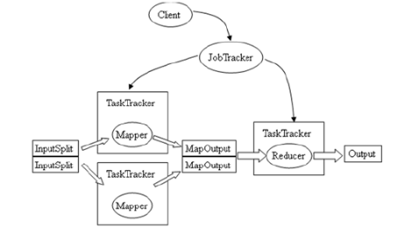
Fig.1. Map Reduce workflow diagram

HDFS stores both the input and output of the MapReduce framework. The MapReduce framework is able to take care of planning, monitoring the tasks and also re-running the failed tasks [12].

The MapReduce framework composed with a single master Job Tracker and one TaskTracker slave for cluster-node. The master is responsible for the management of resources, monitoring of consumption and availability of resources, the planning of the tasks of the members work on the slaves, their monitoring and re-executing the failed tasks. The TaskTracker slaves execute the tasks as directed by the JobTracker, and provide information about the progress of tasks completion [12].

The Job Tracker is the only point of failure for the Hadoop MapReduce service that means that all running processes are stopped if JobTracker goes down.

IV. METHODOLOGY

The Weblog analysis system is implemented by using Hadoop Framework. Hadoop MapReduce framework is used for processing large size semi structured log files data. The weblog data sets are downloaded from source sites and converted into text file format for further processing. Python is used for the MapReduce programming. The hardware and software requirements for the implementation of weblog analysis system using Hadoop are
A. Hardware requirements

Personal computer with 1). Processor: i5-4590 @3.30 GHz.2). RAM : 4 GB. 3). HDD: 500 GB.

- Software requirements

  - VMware Workstation b) Cloudera-quickstart-vm-5.5.0 c) Centos 6.7.

- Experiment set up and process

- Starting Hadoop : After setting all the parameters of system Hadoop can be started by using bin/start-all.sh command. The jps command is used to start NameNode, SecondaryNameNode, SecondaryNode, and JobTracker.
- Weblog Analysis and Processing: Initial state of system consists running Hadoop infrastructure. Figure 2 shows overall working of Weblog analysis system on Hadoop infrastructure.
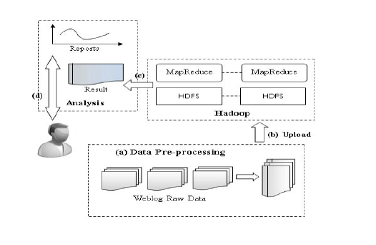
Fig. 2. Web Log Analysis Architecture[1]

In this firstly

(a) The weblog datasets which are in the raw format are converted into text file format as shown in fig 3.

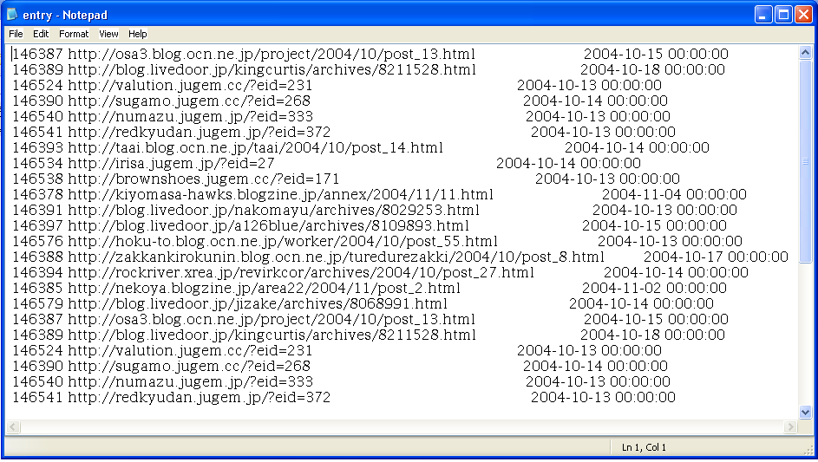
Fig.3. Input Weblog Files in Text File Format

(b) The input file is uploaded on HDFS for processing.
(c) MapReduce Framework is used for processing the input files. In Map phase the input data is converted into inter-mediate data that is in key value pair as shown in fig 4.
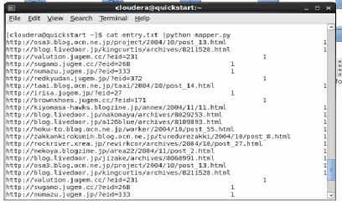
Fig 4. Map phase

(d)In Reduce phase intermediate data is converted into final output by combining all the values associated with a key as shown in fig 5.
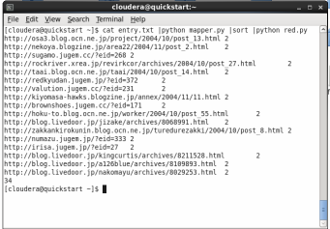
Fig 5. Reduce Phase
(e) Output is moved to Linux file system which is stored in specified directory in text file format. After getting result user can get maximum hit count of particular url of a website.

V. RESULTS AND ANALYSIS

By performing weblog analysis results are come in the form of key value pairs as shown in fig 6. The output of the the program is in key value pair as required.
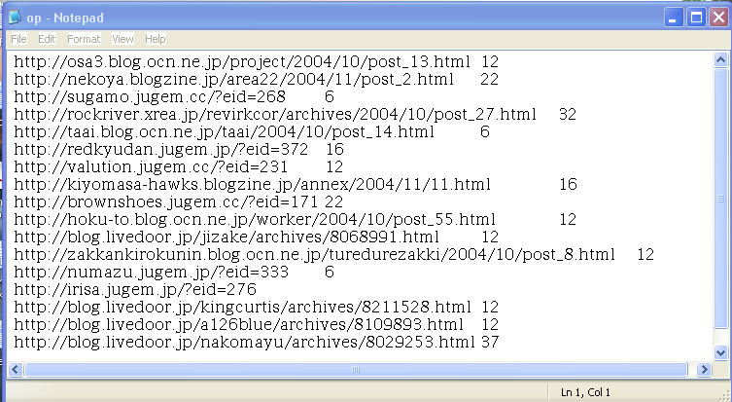
Fig 6. Output Results
The output shows the string as a key is url of a website and the value denotes number of times the particular url is hit by the user in the data. That is the frequency of each url occurred in the particular data.

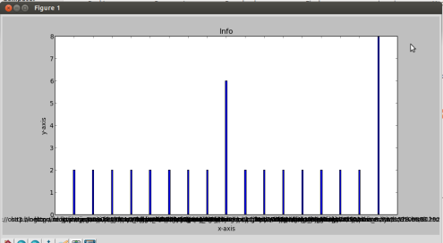
Fig 7. Analysis of Result

From analyzing the results it is possible to conclude about the frequent use of particular url.The graph shown in fig 7 shows the most frequently accessed url. In above graph x-axis denotes link address and y-axis denotes hit count of particular link address. From the graph user can conclude about the frequently accessed url and according to it can make business decisions.

VI. CONCLUSION

In today’s internet world, websites are useful source of information. Number of people are accessing to these websites and requesting number of pages, due to which the log files of these websites are getting bigger every day. These log files are convenient source of information to identify the behavior of the user. As developed weblog analysis system is based on Hadoop framework it is capable to process large data sets of weblog. By experiments it is also concluded that by using Hadoop MapReduce framework, current system can perform large size weblog processing and gives efficient results with less efforts and time. As a future work, Hadoop ecosystem like Pig, Flume, Hive for efficient processing of data can be embed in current system to get more effective analysis result and also can use different data visualization techniques to view the results.

REFERENCES

- Chen-Hau-Wang,Ching Tsorng Tsai ,Chia-Chan Fan,Shyan-Ming Yuan.”A Hadoop based Weblog Analysis System.”7th IEEE Conference 2014.
- Dhara Kalola, Prof. Uday Bhave.”WeblogAnalysis with Map-Reduce and Performance Comparison of Single v/s hadoop Cluster”.IJIRCCE.11
- Siddharth Adhikari, Devesh Saraf, Mahesh Revanwar, Nikhil Ankam.”Analysis of Log Data and Statistics Report Generation Using Hadoop.”IJIRCCE 2014.
- Sayalee Narkhedeand Tripti Baraskar.HMR “Log Analyzer: Analyze Web Application Logs Over Hadoop MapReduce.”IJU July 2013.
- Milind Bhandare, Prof. Kuntal Barua, Vikas Nagare, Dynaneshwar Ekhande, Rahul Pawar,”Generic Log Analyzer Using Hadoop MapReduce Framework.” IJETAE 2013.
- Xiu-yu Zhong.”The research and application of web log mining based on the platform weka.” Procedia Engineering 15 (2011) 4073 – 4078,ScienceDirect.
- Christopher C. Yang and Tobun D. Ng.Terrorism and Crime Related Weblog Social Network:Link, Content Analysis and Information Visualization.
- Songxiang Cen, Li han, Jian Ma.Ranking “Weblogs by Analyzing Reading and Commenting Activities”. 2009 IEEE/WIC/ACM International Conference on Web Intelligence and Intelligent Agent Technology – Workshops
- Lei Wang, Fuji Ren, and Duoqian Miao.”A Novel Method for Recognizing Emotions of Weblog Sentences.” Proceedings of the 2013 IEEE/SICE International Symposium on System Integration, Kobe International Conference Center, Kobe, Japan, December 15-17
- Jianli Duan, Shuxia Liu. “Research on web log mining analysis”. IMSNA 2012.
- D.Borathkar.”The Hadoop Destributed File System:Architecture and Design.”The Apache Foundation 2007.
- Jeffrey Dean and Sanjay Ghemawat., (2004) “MapReduce: Simplified Data Processing on Large Clusters”, Google Research Publication.

